SOCIAL STUDIES
GRADE: V DATE: 19.8.20
NAME:
Worksheet – 8

8. The land of sand
I.FILL IN THE BLANKS
1. An Nafud lies to the ____________________ of Saudi Arabia.
2. From May to September, it is ________________ in Saudi Arabia.
3. One of the features of the plants which grow in Saudi Arabia is that they have _______________ .
4. Saudi Arabia has large reserves of _________________.
5. An area where the underground water comes to the surface is called ____________________.
6.___________________ are nomadic People.
7._____________________________ is a holy city in Saudi Arabia.
II. Complete the sequence
1 .Rub al-Khali: desert in the south : : An Nafud : ___________________ .
2. Jordan: north: : Kuwait : ___________________ .
3 .Summer season: May to September: : winter season : _________________.
4. ___________________: east: : Red sea : west.
5. ___________________ : capital city : : Jeddah : commercial city.
III.LOOK AT THE PICTURE>ANSWER THE QUESTIONS

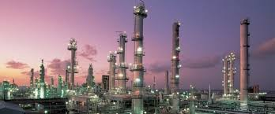
1. What can we see in the picture?

2. Which country is the largest producer of this mineral?

3. Has the discovery of this mineral been beneficial for the people of this country? How?

